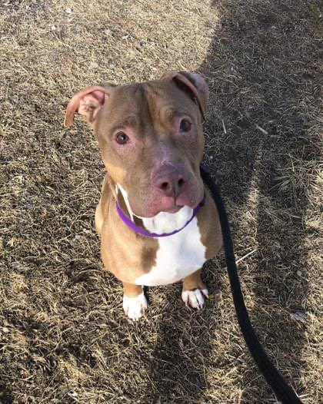
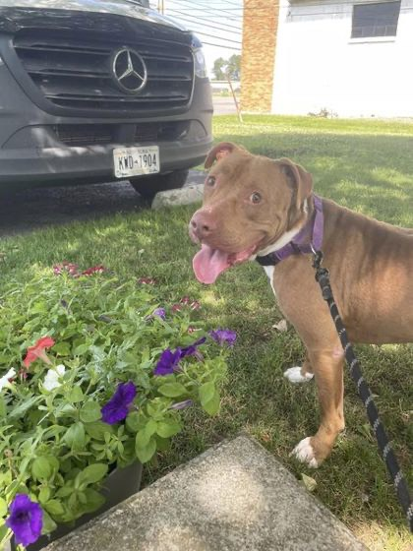
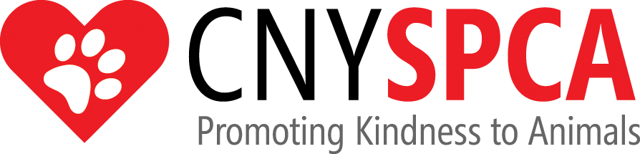

2025 EVERY ANIMAL HAS ITS DAY
GOLF TOURNAMENT

PLAYER REGISTRATION FORM
LARRY

The Central New York SPCA will be hosting our 2025 Every Animal Has Its Day Golf Tournament on Saturday, July 19, 2025 at The Pompey Club. Registration will begin at 12:00 pm with a 1:00 pm shotgun start. Cost $140.00 per golfer or $560.00 per team.

PLAYER #1 LUNCH AND DINNER OPTIONS ARE LISTED ON FLYER

Name
Address
City
Telephone Cell Phone
Email
Lunch Preference:
Dinner Preference:
PLAYER #2
Name
Address
City
Telephone Cell Phone
Email
Lunch Preference:
Dinner Preference:
PLAYER #3
Name
Address
City
Telephone Cell Phone
Email
Lunch Preference:
Dinner Preference:
PLAYER #4
Name
Address
City
Telephone Cell Phone
Email
Lunch Preference:
Dinner Preference:

CNY SPCA
5878 E. Molloy Road
Syracuse, New York 13211
Attention: Golf Tournament

Please mail your payment & registration by: Friday, July 11, 2025

“We speak for those who cannot speak for themselves”
Thank you for your continued support

