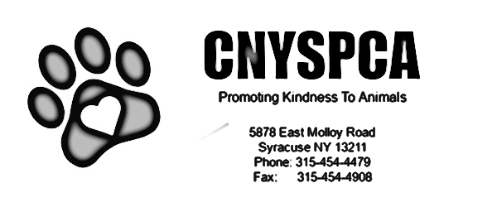

Names of Animal(s) You Are Interested In:___________________________________________________________________________
ADOPTION APPLICATION
All applicants must be 21 years of age or older. Applications are not on a first come, first served basis. Approval is based on what is best for the pet and the applicant.
Name: _________________________________________________________________________________
Address: ________________________________________________________________________________
City:________________________ State:________ Zip:______________ County: ______________________
Phone: ________________________ Email: ___________________________________________________
Home: Own:_____________________ Rent:__________________ Live with Parents: __________________
If you rent, Landlord Name and Phone Number(required): ________________________________________
Number of Adults in the home and ages: ______________________________________________________
Number of Children in the home and ages: ____________________________________________________
Are all family members in agreement with adoption? ____________ If not, please come back when all family members are in agreement.
What is your reason for adopting at this time? Gift / Family Pet / Other
Animal companions need time to settle in (sometimes up to 3 months). Are you willing to take this time and how do you plan to make that process easier?____________________________________________________
What is your level of experience with a dog, cat, critter?
- First Time Pet Owner ______________
- Have Owned one or two pets _______
- Experienced and Knowledgeable (PleaseExplain)______________________________________________________________________________________________________________________________________________________
Does anyone in your family have allergies?_____________ If so, how will you handle this? _______________________________________________________________________________________
The average cost per year to own a dog is about $1500, cats are about $1200 and critters about $800. Is this cost plus unexpected costs for emergencies something that you are prepared for? Please explain ____________________________________________________________________________________________________________________________________________________________________________________
What would you consider acceptable reasons for giving up your companion animal? Circle all that apply.
Fence Jumping Allergies House Soiling Biting Showing Teeth
Hiding Too Active Illness Chewing/Destructive Behavior
Barking Moving Digging Aggression to Other Animals
How would you correct unwanted behaviors? __________________________________________________________________________________________
Have you ever had to give up another pet? When and why? _____________________________________
If something should happen to you, do you have plans in place for your companion animals? If so, what are they?_____________________________________________________________________________________
Have you ever adopted before and from where?________________________________________________
Current Animals In Your Home( We will be calling your veterinary reference. Please call them ASAP and give them permission to talk to us and give the information we request).
Pet’s Name | Species | Age | Spayed/Neutered

Veterinarian’s Practice and Number:__________________________________________________________

Previous Pets(In last 2 years)
Pets Name | Species | Age | What Happened?
Lifestyle:
- Quiet
- Active
- Like To Travel
- Homebody
- Work Full Time
- Work Part Time
Type of Companion Animal You Are Looking For:
- Quiet
- One to share adventures with
- Running/ Hiking Companion
- Couch Buddy
- Dog/Cat Friendly
- Good with Children
Personal Reference:
Name_______________________________ Phone_______________Relationship_______________________

CNYSPCA STAFF RESERVES THE RIGHT TO DECLINE AN APPLICATION IF IT IS NOT A GOOD FIT. ADOPTIONS ARE NOT ON A FIRST COME, FIRST SERVE BASIS, THE ARE BASED ON THE BEST FIT FOR THE ANIMALS.

I certify that the above information is true and correct to the best of my knowledge. I also acknowledge that falsification of the above will result in my being denied adoption of any animal.

Signature: ____________________________________________Date:______________________________

Staff Notes:

