CENTRAL NEW YORK SPCA
Christmas Paint Event
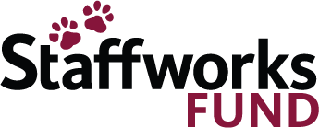
Hosted by The Crazy Chair Lady
Friday, November 4, 2022
Cost: $55.00 / Time: 6:00pm-8:00pm
Location: CNYSPCA – 5878 East Molloy Road, Syracuse, NY
REGISTRATION FORM
Name: _______________________________________________________
Address: _____________________________________________________
Cell Phone Number: _______________________________________________
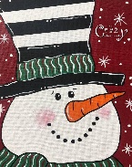
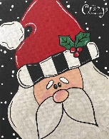
Email Address: _______________________________________________

Santa Claus  Snowman 

PAYMENT INFORMATION
Enclosed is my check in the amount of $_________ (Please make checks payable to the Central New York SPCA)
Please charge my: VISA________ MASTERCARD_______ for the amount of $___________
Credit Card Number: ______________________________ Expiration Date: (mm/yyyy) ___________
Security Code: ____________ (Located on back of card)
Name on Credit Card: _____________________________ Signature: __________________________
Proceeds from this event will go to the shelter animals.
Please return this form with payment to: The Central New York SPCA
Attention: Dr. Cynthia Roundy 5878 East Molloy Road
Email: Drcnythiaroundy@gmail.com Syracuse, New York 13211

Any cancellations are non-refundable.

